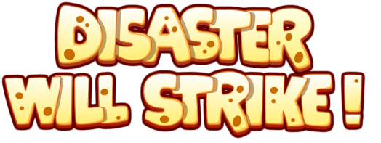
PRESS RELEASE
Disaster Will Strike! 1.1 released for iOS and Android - Interactive Puzzle Game
Moscow – September …, 2016 - Games developer Qaibo Games is proud to announce the worldwide release and availability of their new iOS game – Disaster Will Strike! – now available as a free download on AppStore and Google Play.
The hit online puzzle game that has over 350 million plays. The game has been revamped and re-engineered for mobile devices.
Disaster Will Strike is a creative physics game in which you use natural disasters to solve puzzles. Unleash earthquakes, hurricanes, landslides, comets, and swarms of bees to destroy structures and eliminate the dinosaur eggs.
Price of the game: Free.
AppStore -
Google Play -
Gameplay trailer - https://www.youtube.com/watch?v=xMwLt4DrMaM
Press Kit -
Features:
* Universal App (Phones and Tablets support).
* Retina Screen and Cloud support.
* Apple’s Game Center and Google’s Play Center support.
* Requires iOS 7.1 or later. Compatible with iPhone, iPad, and iPod touch. Optimized for iPhone 7 and 7+.
For more information and review request, send an Email to contact@qaibo.com
ABOUT COMPANY
Qaibo Games is a game development company since 2010. Our goal is to create new and exciting gaming experiences in each our game, and support a casual work atmosphere which encourages communication and creativity.
Web-Page: www.qaibo.com

